1. **Login**

**Prepared by: Ida Bagus Gede Awidya Andika**

* Expanded Use Case

|  |  |
| --- | --- |
| Use Case | Log in |
| Goal in Context | Allow Test Centre Officer to access the website home page |
| Primary Actor  Secondary Actor | Test Centre Officer and Patient  **-** |
| Typical Course of Events | |
| Actor Actions | **System Response** |
| 1. Process begins when the Test Centre Officer/Patient input their username and password and click the login button | 2. System will verify the input data, whether it matches the data in database or not |
|  | 3. System will navigate the user to their homepage/password |
| Alternative Course | |
| 1a: If Test Centre Officer or Patient inputs incorrect username or password, then the system will display a warning notification that includes an instruction to try log in again | |

* System Sequence Diagram

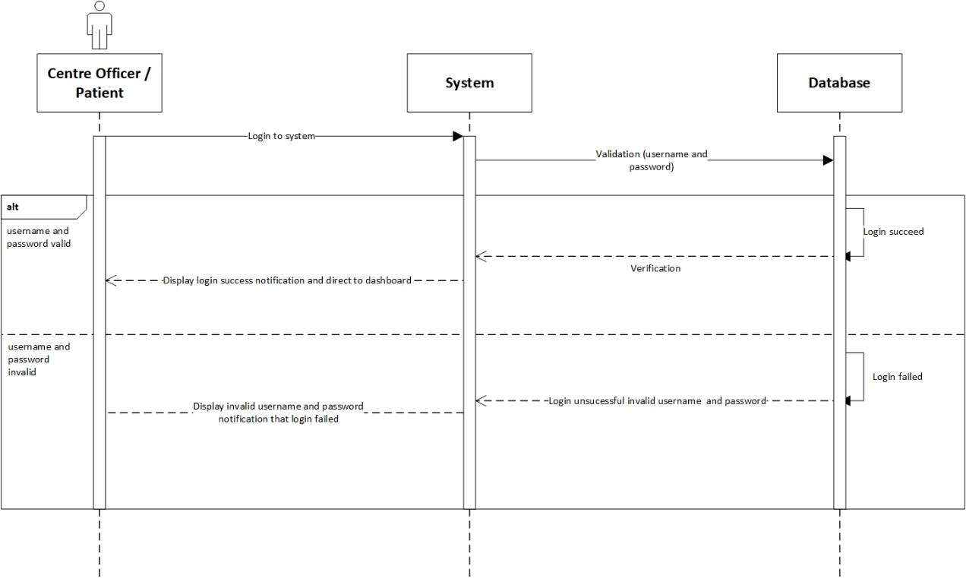

* Contract

|  |  |
| --- | --- |
| **Cross References** | **Login** |
| Operation | Login with username and password. |
| Responsible | To access the main menu page. |
| Pre-conditions | * A valid username is required * A valid password is required |
| Post-conditions | * Username is matched * Password is matched * Display dashboard |

1. **View Test Kit**

**Prepared by: Ida Bagus Gede Awidya Andika**

* Expanded Use Case

|  |  |
| --- | --- |
| Use Case | View identity |
| Goal in Context | Allow Test Centre Manager to view a list of test kit data |
| Primary Actor  Secondary Actor | Test Centre Manager  **-** |
| Typical Course of Events | |
| Actor Actions | **System Response** |
| 1. Process begins after Test Centre Manager has successfully login to system | 1. System will navigate Test Centre Manager to their dashboard |
| 1. Test Centre Manager clicks test kit menu | 1. System displays a list of test kit data |
| Alternative Course | |
| - | |

* System Sequence Diagram

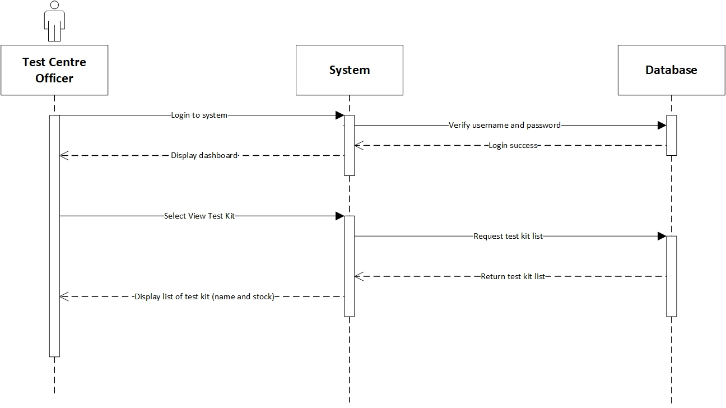

* Contract

|  |  |
| --- | --- |
| **Cross References** | **View Test Kit** |
| Operation | Login with username and password. |
| Responsible | To access the view test kit menu. |
| Pre-conditions | * A valid username is required * A valid password is required |
| Post-conditions | * Username is matched * Password is matched * Display dashboard |
| **Cross References** | **View Test Kit** |
| Operation | View data test kit from test kit menu. |
| Responsible | To view a list of all test kit data. |
| Pre-conditions | Test kit data is already recorded. |
| Post-conditions | A list of test kit data will be displayed. |

1. **Manage Test Kit Stock**

**Prepared by: Ida Bagus Gede Awidya Andika**

* Expanded Use Case

|  |  |
| --- | --- |
| Use Case | View identity |
| Goal in Context | Allow Test Centre Manager to add test kit or update test kit stock |
| Primary Actor  Secondary Actor | Test Centre Manager  **-** |
| Typical Course of Events | |
| Actor Actions | **System Response** |
| 1. Process begins after Test Centre Manager has successfully login to system | 1. System will navigate Test Centre Manager to their dashboard |
| 1. Test Centre Manager clicks test kit menu | 1. System will display a list of test kit data |
| 1. Test Centre Manager clicks add test kit | 1. System will navigate Test Centre Manager to add test kit page and display test kit data form |
| 1. Test Centre Manager fills in the data for the name of the test kit and the amount of stock on the form provided, then clicks the submit button | 1. System will store the data that has been entered by the Test Centre Manager into the database then Test Centre Manager will be directed to the test kit page and a message that notifies success in adding the test kit is displayed |
| Alternative Course | |
| 5a: if test kit is already recorded in the database, Test Centre Manager will be able to update the stock amount of the available test kit | |

* System Sequence Diagram

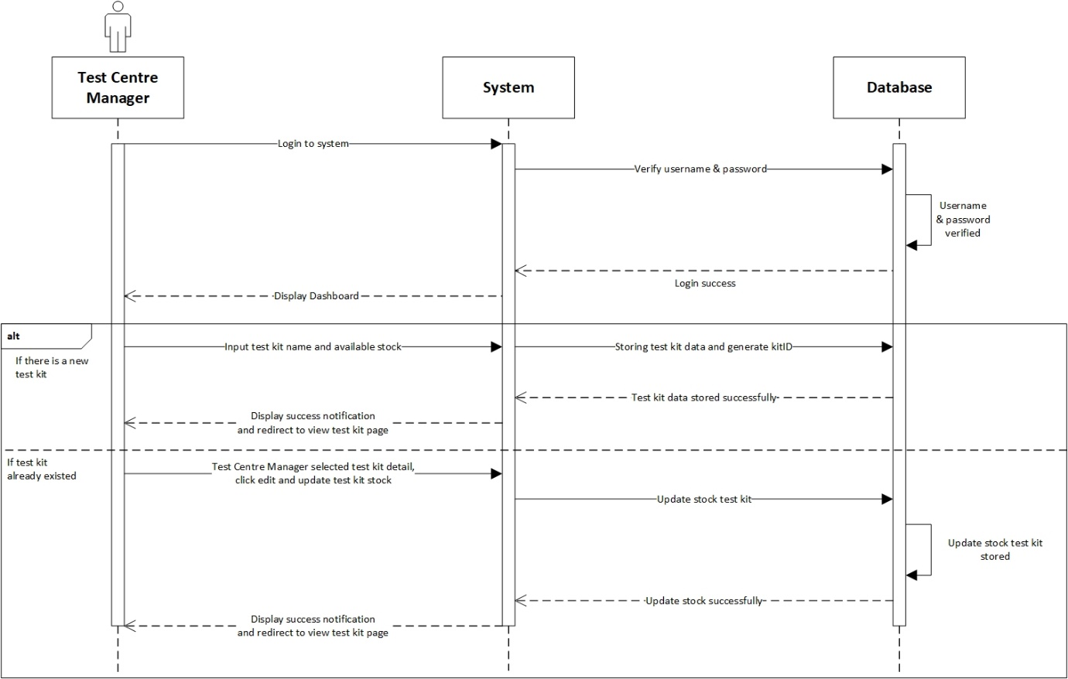

* Contract

|  |  |
| --- | --- |
| **Cross References** | **Manage Test Kit Stock** |
| Operation | Login with username and password. |
| Responsible | To access the manage test kit menu. |
| Pre-conditions | * A valid username is required * A valid password is required |
| Post-conditions | * Username is matched * Password is matched * Display dashboard |
| **Cross References** | **Manage Test Kit Stock** |
| Operation | Manage test kit. |
| Responsible | To add new test kit with name and available stock. |
| Pre-conditions | Object testName and availableStock must be available. |
| Post-conditions | New test kit is successfully added to the system. |
| **Cross References** | **Manage Test Kit** |
| Operation | Manage test kit. |
| Responsible | To update available stock from test kit. |
| Pre-conditions | Detail availableStock must be available. |
| Post-conditions | Stock test kit is updated. |

1. **Register Test Centre**

**Prepared by: Ida Bagus Gede Awidya Andika**

* Expanded Use Case

|  |  |
| --- | --- |
| Use Case | View identity |
| Goal in Context | Allow Test Centre Manager to register test centre |
| Primary Actor  Secondary Actor | Test Centre Manager  **-** |
| Typical Course of Events | |
| Actor Actions | **System Response** |
| 1. Process begins when Test Centre Manager first login to the system | 1. System will navigate Test Centre Manager to register test centre page and display test centre data form |
| 1. Test Centre Manager fills in the name and address of the test centre on the form provided and then clicks the register button | 1. System will store the data that has been inputted by the Test Centre Manager into the database, then Test Centre Manager will be directed to the test centre page and a message that notifies success in registering the test centre is displayed |
| Alternative Course | |
| - | |

* System Sequence Diagram

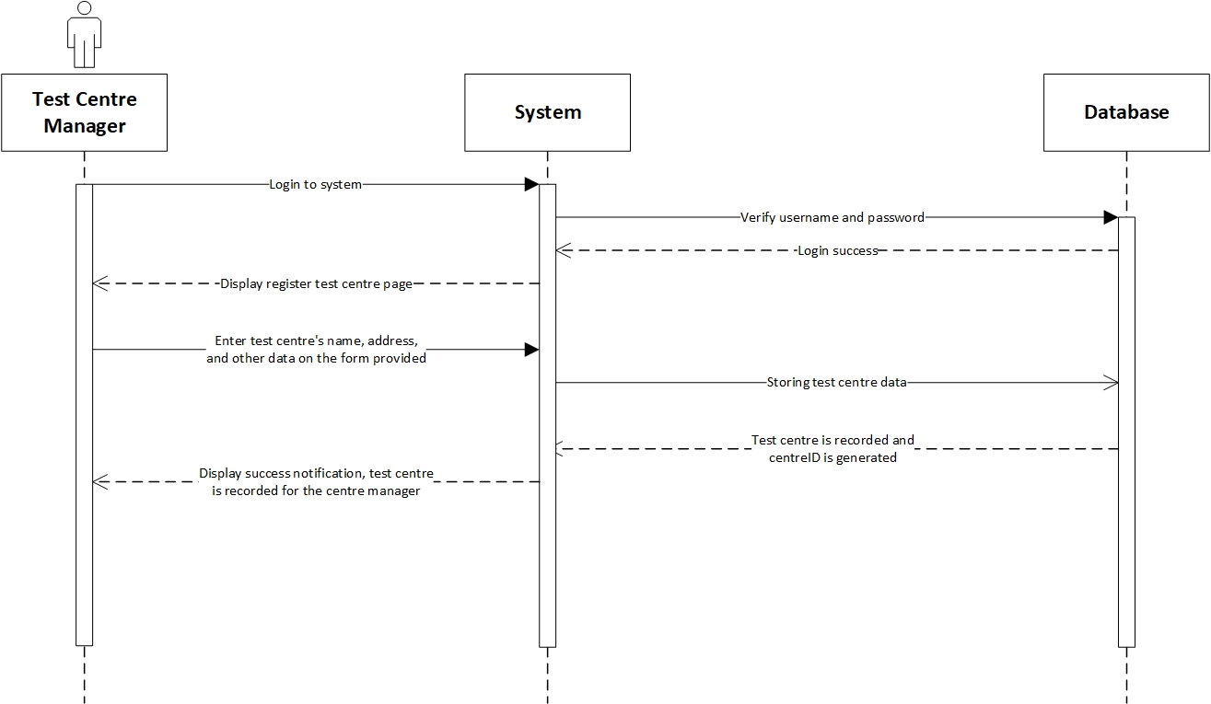

* Contract

|  |  |
| --- | --- |
| **Cross References** | **Register Test Centre** |
| Operation | Login with username and password. |
| Responsible | To access the register test centre menu. |
| Pre-conditions | * A valid username is required * A valid password is required * First login |
| Post-conditions | * Username is matched * Password is matched * Display register test centre page |
| **Cross References** | **Register Test Centre** |
| Operation | Register test centre with name, address, postal code, phone and city from test centre. |
| Responsible | To register test centre and record for test centre manager. |
| Pre-conditions | Following data below that should be available:   * Name test centre * Address * Postal code * Phone * City |
| Post-conditions | Test centre is successfully created and recorded for the centre manager. |

1. **View Test Centre Officer**

**Prepared by: Ida Bagus Gede Awidya Andika**

* Expanded Use Case

|  |  |
| --- | --- |
| Use Case | View identity |
| Goal in Context | Allow Test Centre Officer to view a list of test centre officer data |
| Primary Actor  Secondary Actor | Test Centre Officer  **-** |
| Typical Course of Events | |
| Actor Actions | **System Response** |
| 1. Process begins after Test Centre Officer has successfully login to system | 1. System will navigate Test Centre Officer to their dashboard |
| 1. Test Centre Officer clicks test centre officer menu | 1. System will display a list of test centre officer data |
| Alternative Course | |
| - | |

* System Sequence Diagram

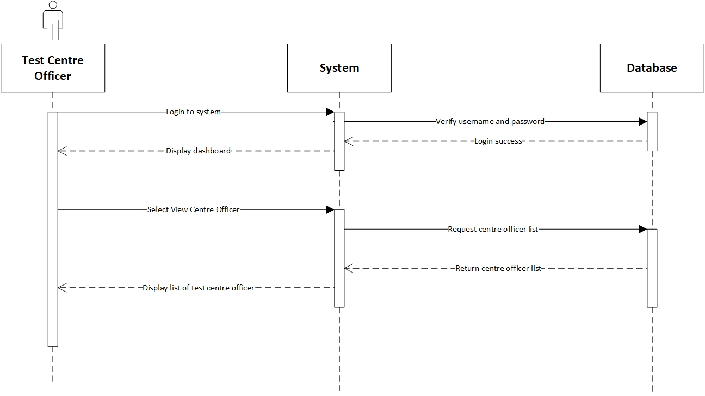

* Contract

|  |  |
| --- | --- |
| **Cross References** | **View Test Centre Officer** |
| Operation | Login with username and password. |
| Responsible | To access the view test centre officer menu. |
| Pre-conditions | * A valid username is required * A valid password is required |
| Post-conditions | * Username is matched * Password is matched * Display dashboard |
| **Cross References** | **View Test Centre Officer** |
| Operation | View data test centre officer from test centre officer menu. |
| Responsible | To view a list of test centre data. |
| Pre-conditions | Test centre officer data is already recorded. |
| Post-conditions | A list of test centre officer data will be displayed. |

1. **Record Tester**

**Prepared by: I Made Siva Aditya Surya**

* Expanded Use Case

|  |  |
| --- | --- |
| Use Case | View identity |
| Goal in Context | Allow Test Centre Manager to record tester |
| Primary Actor  Secondary Actor | Test Centre Manager  Test Centre Officer |
| Typical Course of Events | |
| Actor Actions | **System Response** |
| 1. Process begins after Test Centre Manager successfully login to system | 1. System will navigate Test Centre Manager to their dashboard |
| 1. Test Centre Manager clicks test centre officer menu | 1. System will display a list of test centre data |
| 1. Test Centre Manager clicks edit button on the test centre officer whose position is going to be changed to tester | 1. System will navigate Test Centre to the test centre officer edit page and display the test centre officer data form |
| 1. Test Centre Manager changes the position of test centre officer from “officer” to “tester” | 1. System will store the data that has been entered by the Test Centre Manager into the database then the Test Centre Manager will be navigated to the test centre officer page and a message appears that notify success in recording tester is displayed |
| Alternative Course | |
| 5a: If there are no test centre officer that has been recorded in database or test centre manager wants to record new test centre officer with position “tester”, then the test centre manager will clicks add centre officer button and fill in all the required data in the form as well as setting the position to “tester”. Test centre manager will click the submit button to record the tester into database, then a message that notify success in recording tester is displayed | |

* System Sequence Diagram

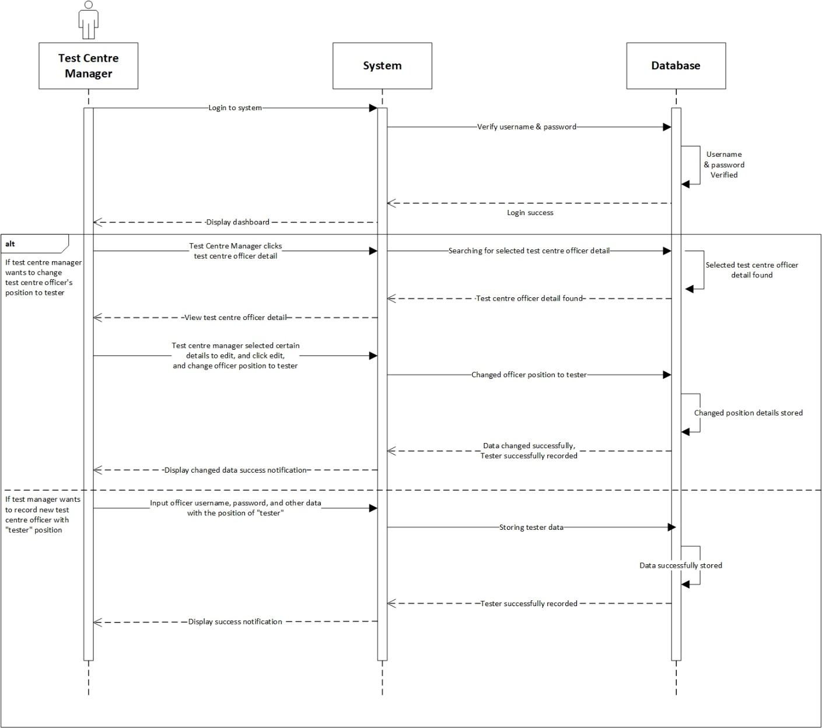

* Contract

|  |  |
| --- | --- |
| **Cross References** | **View Test Centre Officer** |
| Operation | Login with username and password. |
| Responsible | To access the view test centre officer menu. |
| Pre-conditions | * A valid username is required * A valid password is required |
| Post-conditions | * Username is matched * Password is matched * Display dashboard |
| **Cross References** | **View Test Centre Officer** |
| Operation | View data test centre officer from test centre officer menu. |
| Responsible | To view all list data test centre. |
| Pre-conditions | Test centre officer data is already recorded. |
| Post-conditions | A list of test centre officer data will be displayed. |

1. **Record Officer**

**Prepared by: I Made Siva Aditya Surya**

* Expanded Use Case

|  |  |
| --- | --- |
| Use Case | View identity |
| Goal in Context | Allow Test Centre Manager to record test centre officer |
| Primary Actor  Secondary Actor | Test Centre Manager  Test Centre Officer |
| Typical Course of Events | |
| Actor Actions | **System Response** |
| 1. Process begins after Test Centre Manager successfully login to system | 1. System will navigate Test Centre Manager to their dashboard |
| 1. Test Centre Manager clicks test centre officer menu | 1. System will display a list of test centre officer data |
| 1. Test Centre Manager clicks add test centre officer button | 1. System will navigate Test Centre Manager to add test centre officer page and display test centre officer data form |
| 1. Test Centre Manager fills in the data for username, password, and other test centre officer data on the form provided and then clicks the submit button | 1. Sistem will store the data that has been entered by Test Centre Manager into the database then Test Centre Manager will be navigated to the test centre officer page and a message that notifies success in recording test centre officer is displayed |
| Alternative Course | |
| - | |

* System Sequence Diagram

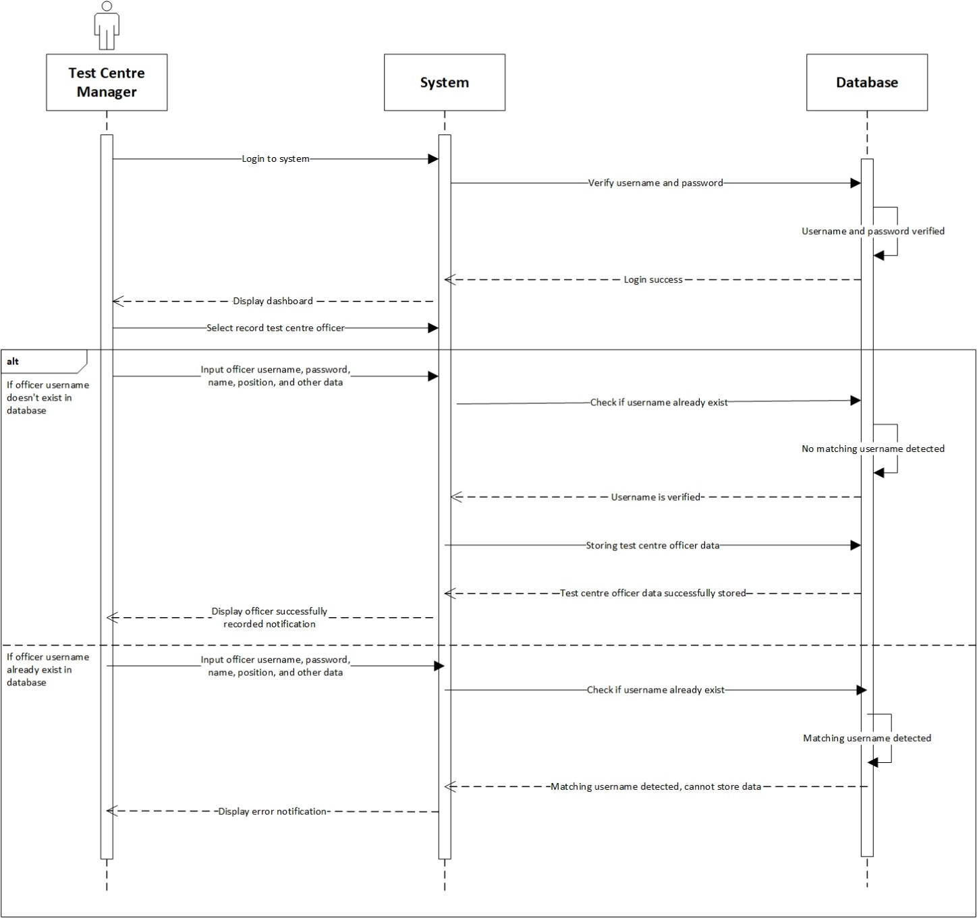

* Contract

|  |  |
| --- | --- |
| **Cross References** | **Record Officer** |
| Operation | Login with username and password. |
| Responsible | To access the record officer menu. |
| Pre-conditions | * A valid username is required * A valid password is required |
| Post-conditions | * Username is matched * Password is matched * Display dashboard |
| **Cross References** | **Record Officer** |
| Operation | Record test centre officer with username, password, name, email, phone, gender, address, age and birth date. |
| Responsible | To be recorded in system and able to access the test centre dashboard. |
| Pre-conditions | Following data below that should be available:   * Username * Password * Name * Email * Phone * Gender * Address * Age * Birth Date |
| Post-conditions | * Username has not been used. * Recorded in system. * Display dashboard. |
| **Cross References** | **Record Officer** |
| Operation | Record test centre officer with username, password, name, email, phone, gender, address, age and birth date. |
| Responsible | To be recorded in system and able to access the test centre dashboard. |
| Pre-conditions | Following data below that should be available:   * Username * Password * Name * Email * Phone * Gender * Address * Age * Birth Date |
| Post-conditions | * Username already exists. * Test Centre Manager must re-enter new username. * Display dashboard. |

1. **Record New Test**

**Prepared by: I Made Siva Aditya Surya**

* Expanded Use Case

|  |  |
| --- | --- |
| Use Case | View identity |
| Goal in Context | Allow Test Centre Tester to record new Covid Test report |
| Primary Actor  Secondary Actor | Tester  Patient |
| Typical Course of Events | |
| Actor Actions | **System Response** |
| 1. Process begins after Tester successfully login to system | 1. System will navigate Tester to their dashboard |
| 1. Tester clicks Patient Test menu | 1. System will display a list of Patient Test data |
| 1. Tester clicks add new test button | 1. System will navigate Tester to add new test page and display patient data and test data form |
| 1. Tester fills in the patient username, password, and other patient data, as well as test-related data which includes patient type and symptoms in the form provided and then clicks the submit button | 1. System will store the data that has been entered by Tester into the database then the Tester will be directed to the Patient Test page and a message that notifies success in recording new test is displayed |
| Alternative Course | |
| 5a: If patient has already done the test before, then Tester only needs to enter patient type and symptoms into the form provided | |

* System Sequence Diagram

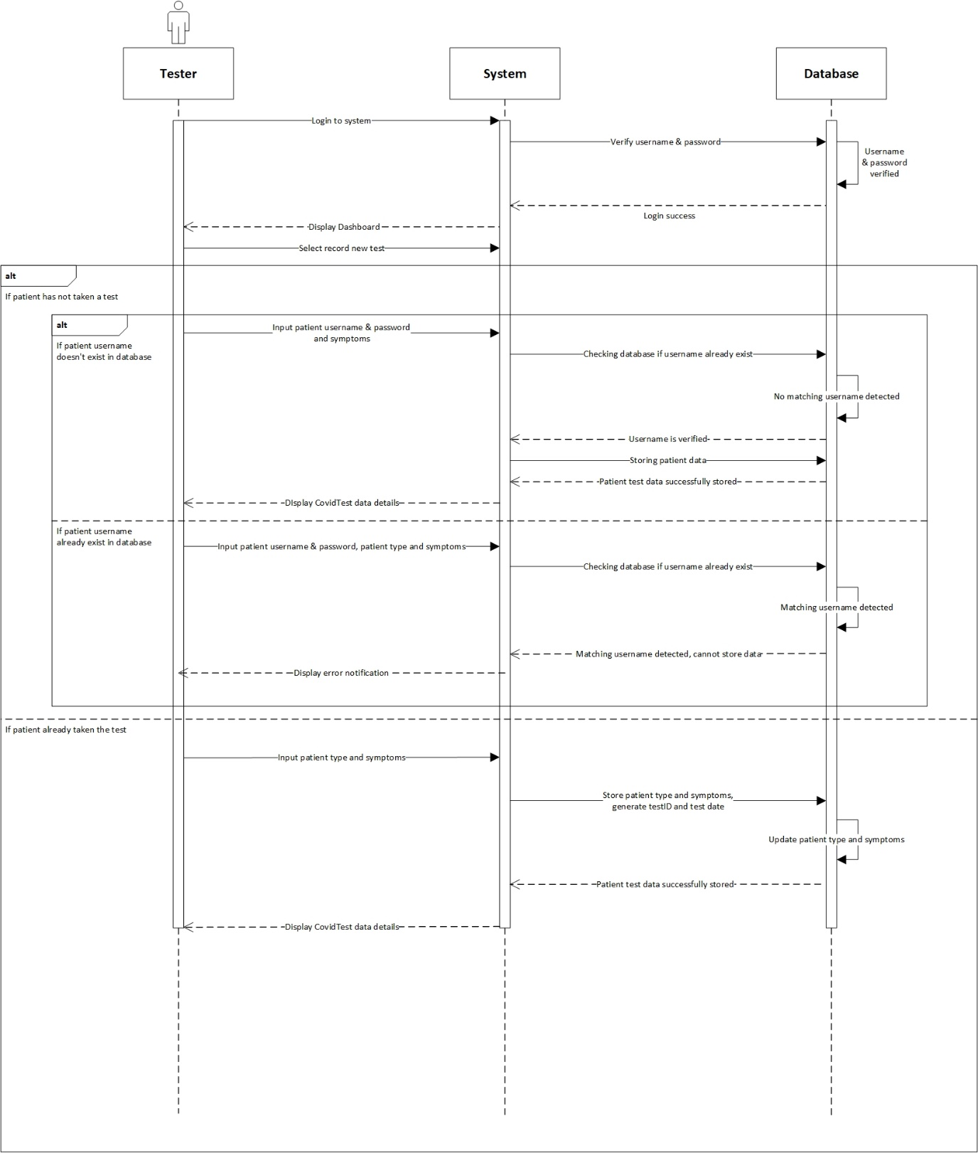

* Contract

|  |  |
| --- | --- |
| **Cross References** | **Record New Test** |
| Operation | Login with username and password. |
| Responsible | To access the record new test menu. |
| Pre-conditions | * A valid username is required * A valid password is required |
| Post-conditions | * Username is matched * Password is matched * Display dashboard |
| **Cross References** | **Record New Test** |
| Operation | Record tester with username, password and symptoms. |
| Responsible | To be recorded in system if patient has not taken the test. |
| Pre-conditions | Following data below that should be available:   * Username * Password * Name * Email * Phone No * Gender * Address * Age * Birth Date * Symptoms |
| Post-conditions | * Username, password and symptoms has not been recorded. * Successfully added to system. * Display dashboard. |
| **Cross References** | **Record New Test** |
| Operation | Record tester with username, password, patient type and symptoms. |
| Responsible | To be recorded in system if patient has not taken the test but already registered an account. |
| Pre-conditions | Following data below that should be available:   * Username * Password * Patient type * Symptoms |
| Post-conditions | * Username, password, patient type and symptoms are matched. * Display dashboard. |
| **Cross References** | **Record New Test** |
| Operation | Record tester with patient type and symptoms. |
| Responsible | To be recorded in system that if patient has taken the test. |
| Pre-conditions | Following data below that should be available:   * Patient type * Symptoms |
| Post-conditions | The list of the patient details will be display. |

1. **Update Test Result**

**Prepared by: I Made Siva Aditya Surya**

* Expanded Use Case

|  |  |
| --- | --- |
| Use Case | View identity |
| Goal in Context | Allow tester to update patient test result data |
| Primary Actor  Secondary Actor | Tester  **-** |
| Typical Course of Events | |
| Actor Actions | **System Response** |
| 1. Process begins after Tester successfully login to system | 1. System will navigate Tester to their dashboard |
| 1. Tester clicks Patient Test menu | 1. System will display a list of patient test data |
| 1. Tester clicks the edit button on the test patient data that needs to be updated | 1. System will navigate Tester to edit test patient page and display patient test data form |
| 1. Tester updates patient status data and result | 1. System will store the data that has been entered by Tester into the database then Tester will be navigated to the Patient Test page and a message that notifies success in updating patient test data is displayed |
| Alternative Course | |
| - | |

* System Sequence Diagram

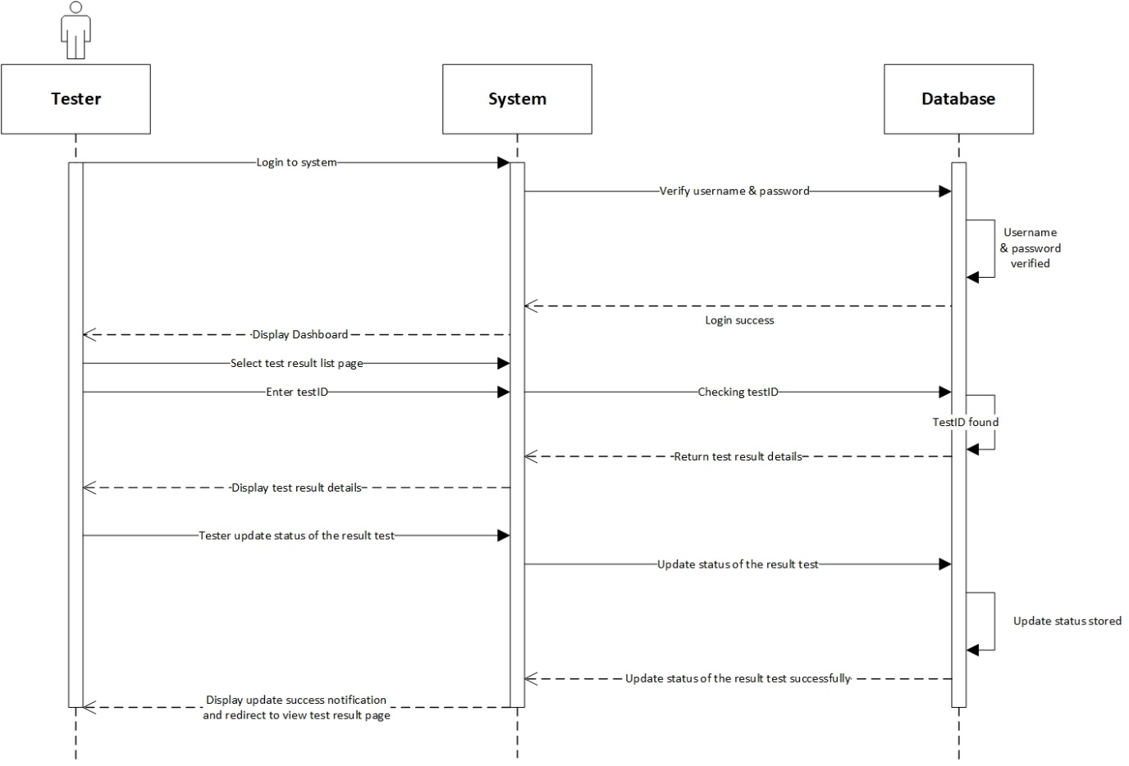

* Contract

|  |  |
| --- | --- |
| **Cross References** | **Update Test Result** |
| Operation | Login with username and password. |
| Responsible | To access the update test result menu. |
| Pre-conditions | * A valid username is required * A valid password is required |
| Post-conditions | * Username is matched * Password is matched * Display dashboard |
| **Cross References** | **Update Test Result** |
| Operation | Update test result of the tester. |
| Responsible | To update the result test status of the tester. |
| Pre-conditions | The test result and testID must be available. |
| Post-conditions | Test result and status is updated. |

1. **Generate Test Report**

**Prepared by: I Made Siva Aditya Surya**

* Expanded Use Case

|  |  |
| --- | --- |
| Use Case | View identity |
| Goal in Context | Allow Test Centre Officer to view a history of patient test report |
| Primary Actor  Secondary Actor | Test Centre Officer  **-** |
| Typical Course of Events | |
| Actor Actions | **System Response** |
| 1. Process begins after Test Centre Officer successfully login to system | 1. System will navigate Test Centre Officer to their homepage |
| 1. Test Centre Officer clicks Test Report menu | 1. System will display a list of all patient test report on the test centre which the officer is employed at |
| Alternative Course | |
| - | |

* System Sequence Diagram

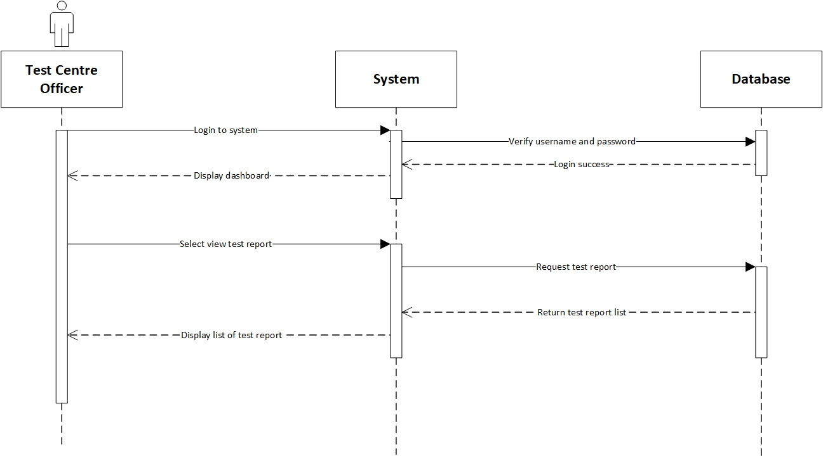

* Contract

|  |  |
| --- | --- |
| **Cross References** | **Generate Test Report** |
| Operation | Login with username and password. |
| Responsible | To access the generate test report menu. |
| Pre-conditions | * A valid username is required * A valid password is required |
| Post-conditions | * Username is matched * Password is matched * Display dashboard |
| **Cross References** | **Generate Test Report** |
| Operation | View data test report from test centre officer menu. |
| Responsible | To view a list of all test report data. |
| Pre-conditions | The test centre officer object and test report must be available. |
| Post-conditions | A list of test report will be displayed. |

1. **View Testing History**

**Prepared by: I Made Siva Aditya Surya**

* Expanded Use Case

|  |  |
| --- | --- |
| Use Case | View identity |
| Goal in Context | Allow Test Centre Officer to view a list of test centre officer data |
| Primary Actor  Secondary Actor | Test Centre Officer  **-** |
| Typical Course of Events | |
| Actor Actions | **System Response** |
| 1. Process begins after Test Centre Officer has successfully login to system | 1. System will navigate Test Centre Officer to their dashboard |
| 1. Test Centre Officer clicks test centre officer menu | 1. System will display a list of test centre officer data |
| Alternative Course | |
| - | |

* System Sequence Diagram

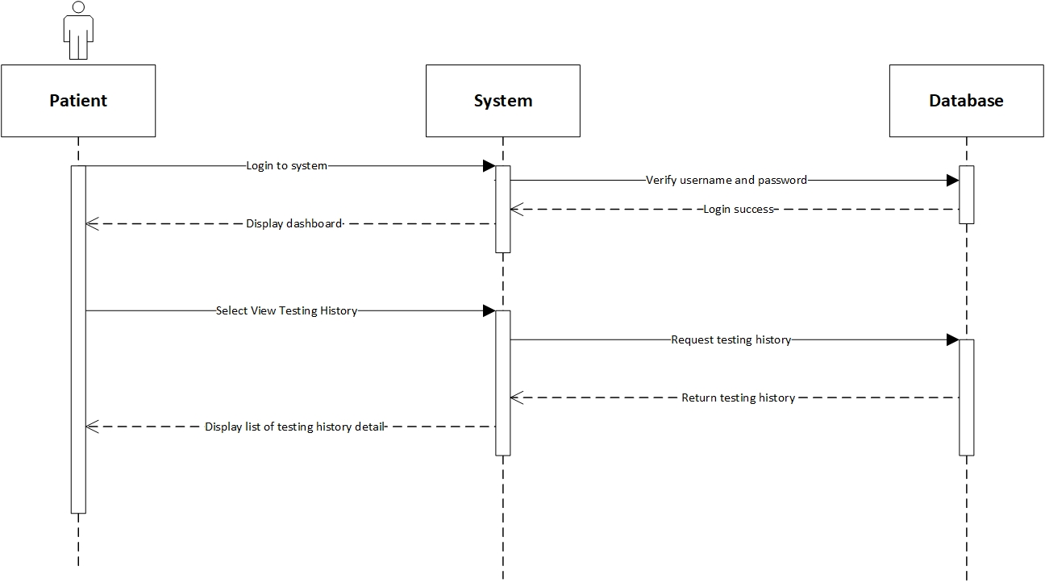

* Contract

|  |  |
| --- | --- |
| **Cross References** | **View Testing History** |
| Operation | Login with username and password. |
| Responsible | To access the view testing history menu. |
| Pre-conditions | * A valid username is required * A valid password is required |
| Post-conditions | * Username is matched * Password is matched * Display dashboard |
| **Cross References** | **View Testing History** |
| Operation | View testing history from patient menu. |
| Responsible | To view a list of all testing report data. |
| Pre-conditions | The patient object and testing report history must be available. |
| Post-conditions | A list of testing history will be displayed. |

1. **Log out**

**Prepared by: Ida Bagus Gede Awidya Andika**

* Expanded Use Case

|  |  |
| --- | --- |
| Use Case | Log out |
| Goal in Context | Allow Test Centre Officer and Patient to log out from the website system |
| Primary Actor  Secondary Actor | Test Centre Officer and Patient  **-** |
| Typical Course of Events | |
| Actor Actions | **System Response** |
| 1. Process begins after Test Centre Officer/Patient has done everything they want to do on the system and wants to log out |  |
| 1. Test Centre Officer/Patient clicks logout button | 1. System will display a message questioning whether Test Centre Officer/Patient really wants to log out from system |
| 1. Test Centre Officer/Patient clicks Yes on the message | 1. System will end the login session of the Test Centre Officer/Patient and redirect to login page |
| Alternative Course | |
| 4a: If the officer/patient clicks on the No button, the log out process will be canceled | |

* System Sequence Diagram

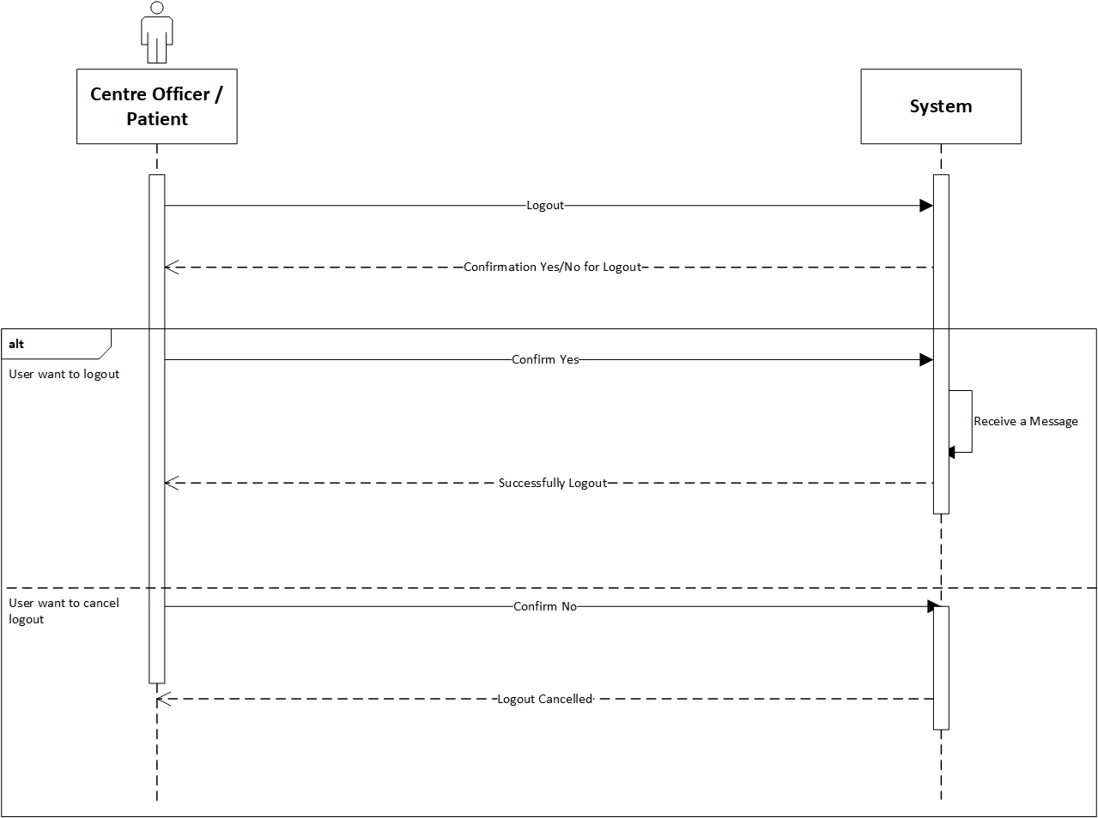

* Contract

|  |  |
| --- | --- |
| **Cross References** | **Logout** |
| Operation | Centre officer or patient want to log out |
| Responsible | To log out or exit from the system |
| Pre-conditions | The centre officer or patient accepts that they want to log out |
| Post-conditions | Success log out from the system. |
| **Cross References** | **Logout** |
| Operation | Cancel to log out |
| Responsible | To cancel log out or exit from the system |
| Pre-conditions | The centre officer or patient want to cancel the log out. |
| Post-conditions | Cancel log out from the system |